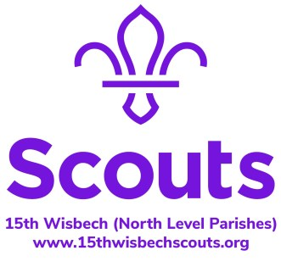
Food Tower
Create a tower made only of things you can eat.
Prizes will be awarded for…
- The tallest tower
- The most different types of food used
Towers must be free standing
The tower must not be made of anything you cannot eat (eg; packaging)
Cocktail sticks, glue and skewers are not edible so cannot be used
Different brands/flavours do not count as different foods
You can build your tower however you want. It can be straight up, a pyramid, anything you like (although bonus points will be awarded for spheres).
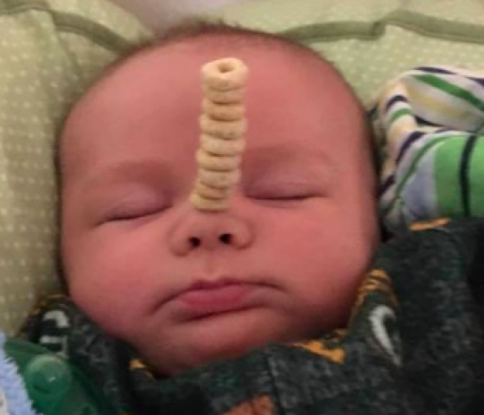
To enter your towers;
- Take a picture of you and your tower
- Measure your tower with a tape measure or ruler from the base to the highest point (please be honest, besides, a scout is to be trusted)
*Please get your baby’s permission before using them as foundations for any food tower.
- Send the picture and measurement to your section leader
*Do not use all of the food in your house as eating is actually quite important!

